Lakeside Labs (LL)
and
Inst for Networked & Embedded Systems (NES)
Inst for Applied Informatics (IAI)
at
Alpen-Adria-Universität Klagenfurt (KLU)
Dept of Communication Systems (DCS)
Dept of Knowledge Technologies (DKT)
Dept of Intelligent Systems (DIS)
at
Jozef Stefan Institute (JSI)

‘Get-to-know’ Meeting

When:
10th June 2009 at 10am

Where:
Jozef Stefan Institute, Jamova cesta 39, 1000 Ljubljana

Room:
Orange Room

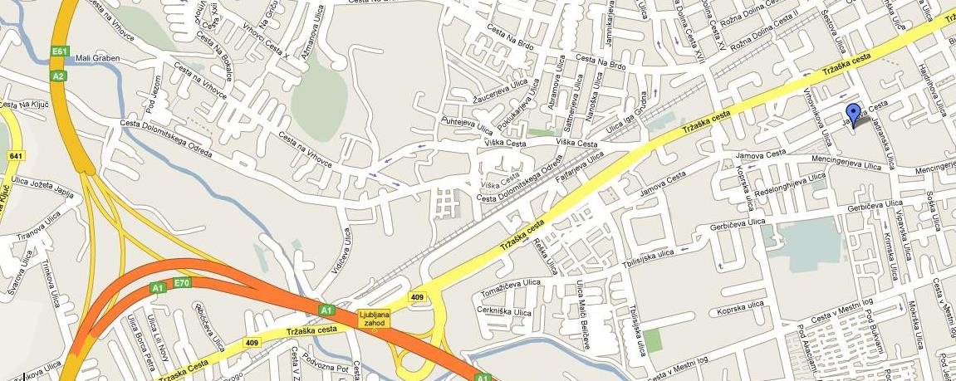

Purpose:
The purpose of this ‘get-to-know’ meeting is to bring together researchers in the area of wireless communications, embedded systems, knowledge technologies and intelligent systems to present their research activities and interests, discuss research ideas and plans, and try to identify potential collaboration opportunities.

Agenda:
10:00-10:15 | Welcome address and overview of JSI by dr. Boris Pukl, asst. director of JSI
10:15-11:00 | Overview presentation of KLU (NES and IAI) and LakesideLabs
11:00-11:15 | Coffee Break
11:15-12:00 | DCS overview presentation (research areas and expertise, main equipment, past & present projects, …) |  | DIS overview presentation and discussions on potential collaboration with IAI
12:00-12:45 | Discussions between NES and DCS on potential collaboration topics and platforms | Research management from LL visits Technology Transfer Office at JSI | DKT overview presentation and discussions on potential collaboration with IAI
12:45-13:30 | Individual discussions and/or visit of WSN Lab (short demo of ongoing projects)…
13:45-… | Joint lunch (location to be announced at the beginning of the meeting)

Orange room
E7 meeting room
Technology Transfer Office

Attendees:

Inst for Networked & Embedded Systems (NES)
Prof. Dr. Christian Bettstetter
Dr. Wilfried Elmenreich
Dr. Evsen Yanmaz
Dipl.-Ing. Helmut Adam

Inst for Applied Informatics (Intelligent Systems and Business Informatics) (IAI)
Prof. Dr. Gerhard Friedrich

Lakeside Labs GmbH (LL)
Mag. Claudia Prüggler
Mag. Thomas Ladstätter
Dr. Petra Hössl

Dept of Communication Systems (DCS)
Doc. Dr. Mihael Mohorcic
Miha Smolnikar
Carolina Fortuna

Dept of Knowledge Technologies (DKT)
Doc. Dr. Martin Žnidaršič

Dept of Intelligent Systems (DIS)
Prof. Dr. Bogdan Filipič
Robert Blatnik

Technology Transfer Office (TTO)
Dr. Špela Stres

Contact:
Miha Smolnikar
E-mail: Miha.Smolnikar@ijs.si
Phone: +386 (0)1 477 31 34
Mobile: +386 (0)31 819 000

